**Section 17 done: 22/22 Redux Advanced: Burger Project**  
**Introduction**  
* We also want to make sure that we can store this new order we create here - once it was successfully stored on the server - also locally so that when we visit orders, we can see it there.  
* We’re going to add Redux for handling our orders, for fetching them for the server for example, and we’ll also optimize our REDUCERs a little bit.  
**Installing the Redux Devtools**  
* We’ll also want to use the default ingredients set up on the server - though it’s for demo purposes, in a real app it might of course also make sense to initialize the ingredients in your code.  
* Right now we don’t need the Advanced store setup for Redux Devtools - we’ll use that later - when we use MIDDLEWARE. Since I got no other enhancers, we’re not using any MIDDLEWARE yet, we can go with the basic setup for now.  
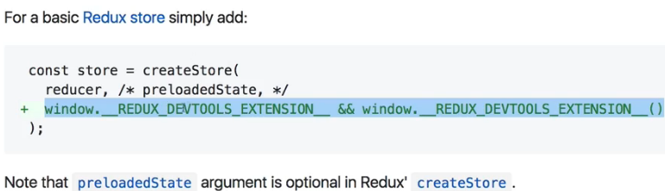  
  
**Preparing the Folder Structure**  
* Let’s start working on the state for ordering a burger.  
* Right now we handle that inside of our `ContactData.js` container. There we have the orderHandler() method, which is essentially executed when we submit this form we create in this container. And in this orderHandler() we set an HTTP Request, we set the state to `loading`: true initially to show a Spinner, then we set it to false once we’re done and then we navigate away to “/”.  
* We can do all of that in that container, this is not per se wrong, but we can also outsource it to **ACTION CREATORs** and Redux.  
* Since in theory you could have an application where you also want to be able to submit this Request from other pages too, maybe putting it into a central place like the Redux STORE is, is a good idea.  
=> We’re going to move that submit logic out of this ContactData.js container into an ACTION CREATOR.  
* Creating `**actions**` folder.  
* Creating `**reducers**` folder.  
* Renaming `actions.js` to `actionTypes.js`.  
* `order.js` in `actions` folder should hold the ACTION CREATORs for submitting an order.  
* `order.js` as another file in `reducers` folder too and `burgerBuilder.js` file since it holds code relevant to building the burger only, not just to the ingredients, but in theory to the whole building process if we were to add more functionalities to it.  
* Also adding `burgerBuilder.js` file to the `actions` folder, where I want to create the ACTION CREATORs for building a burger and there I’ll only have Synchronous ACTION CREATORs for adding/removing ingredients but still I want to keep that ACTION CREATOR pattern throughout my application here, even though for Synchronous ACTION CREATORs it’s not really necessary, but it is a consistent approach I’m taking here.  
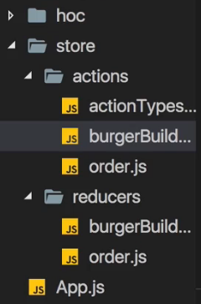  
* Let’s start working on these ACTION CREATORs before we then start implementing the store handling for orders.  
**Creating Action Creators**   
* ACTION CREATOR name the same as the ACTION IDENTIFIER but camelCase.  
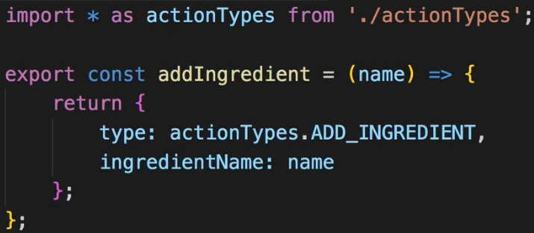  
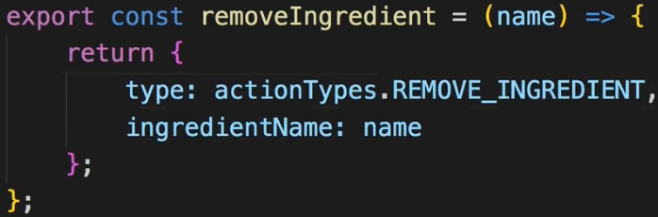  
* Let’s also adjust the paths for our imports.  
* Creating `index.js` for ACTION CREATORs  
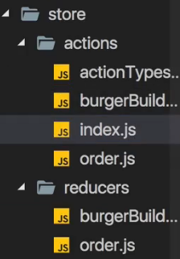 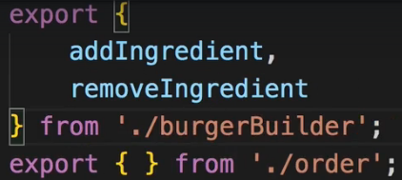  
* Now in BurgerBuilder.js:  
* Due to our workflow setup, you can even omit /index in the end, it’ll automatically pick the index.js file if you point at a folder.  
  
  
* Now it works just as before but now with the help of our ACTION CREATORs.  
**Executing Asynchronous Code**  
* Before we handle our orders with Asynchronous code, we got 1 piece of Asynchronous code we can execute right away though - in the Burgerbuilder.js container we used to fetch our ingredients from componentDidMount():  
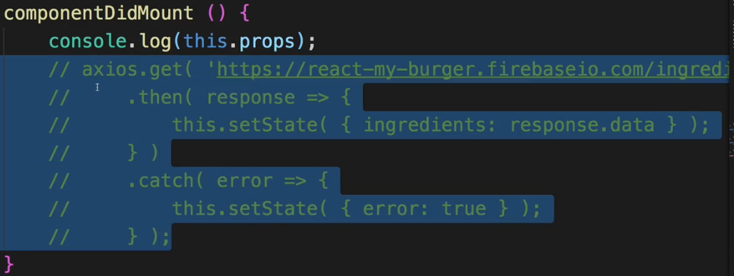  
* And I paused this temporarily when we switched to Redux.  
* Now is the time to again fetch this.  
* **There are 2 routes you can take - you can comment in the old code in componentDidMount() and then instead of calling `this.setState()` here, you could dispatch some -to be created- ACTION which updated our ingredients in the Redux STORE. Then you would run the Async code in your component and you wouldn’t need ACTION CREATORs at all because you just dispatch normal ACTIONs in the end, once the response is there. That is perfectly fine to do**.  
* **But the idea behind ACTION CREATORs is that you can still put your Async code into the Redux world. That’s the route I wanna take here**.  
**npm install --save redux-thunk**  
* That’s this MIDDLEWARE which allows us to use Asynchronous code in ACTION CREATORs due to the MIDDLEWARE, wrapping itself around the dispatch ACTION and blocking the Request until the Async code is done so to say.  
* In main `index.js`:  
  
  
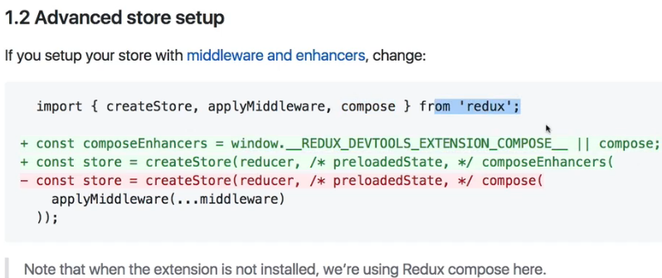  
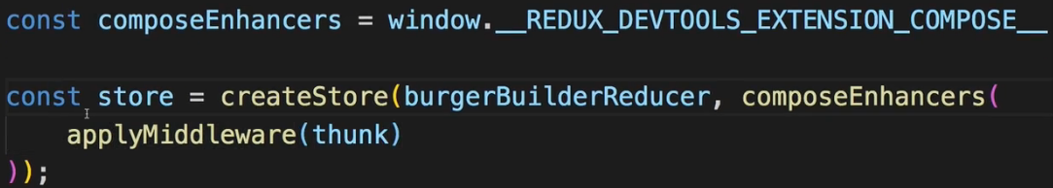  
* `compose` allows us to compose our own set of enhancers and MIDDLEWARE is just 1 kind of enhancer, devtools would be another example.  
* Now we can start writing Async code in our ACTION CREATORs.  
* Let’s do that for fetching the ingredients we may add.  
**Fetching Ingredients Asynchronously**  
* Let’s do that in the `burgerBuilder.js` in the `actions` folder.  
* I want to return a function where I receive the `dispatch` function which I can then use in this function body. And this syntax is available due to redux-thunk, which allows me to use my ACTION CREATORs like this.  
* In `actionTypes.js`:  
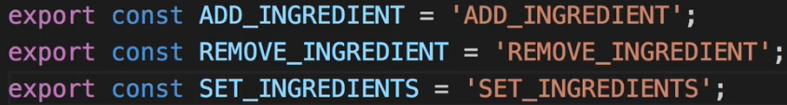  
* Back in `burgerBuilder.js`:  
* Our Synchronous ACTION CREATOR:  
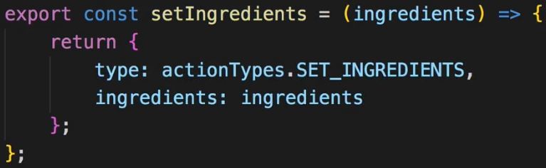  
* I can remove the `error` and `loading` from the state in `BurgerBuilder.js` container because we won’t manage these state fields in `BurgerBuilder.js` anymore.  
* This part we’re going to handling using props instead of state.  
  
* In burgerBuilder.js REDUCER:  
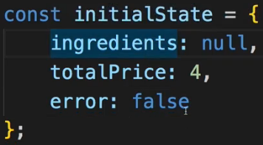  
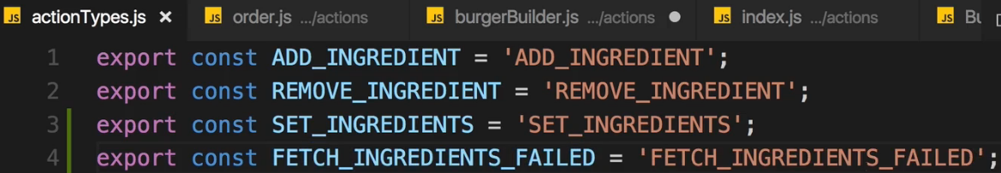  
* In `burgerBuilder.js` `actions` folder:  
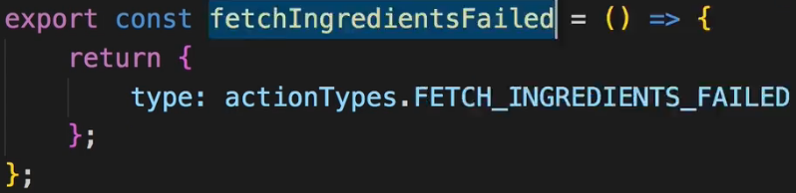  
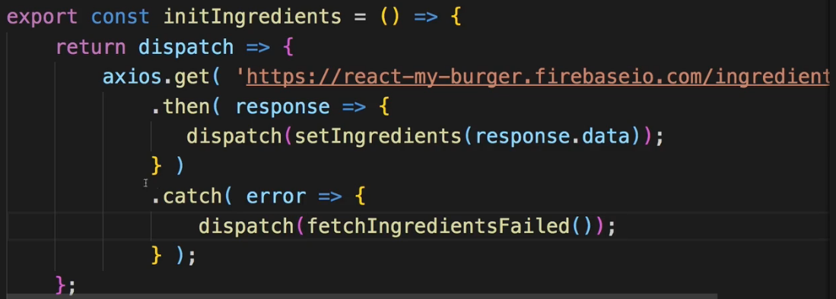  
* Now we need to handle these new ACTIONs in the REDUCER and also make sure that we connect our BurgerBuilder.js correctly to these new things like for example the `error` state.  
* Now 1 important note about that - we can still handle the erros with our HOC here because we’re using an `axios instance` so no matter if we do send a Request from another place in the app like our Async ACTION CREATOR, we can still handle it with that same `axios instance` which we’re passing to the HOC to show our error Modal, which of course is what we wanna do still, we want to have this central error handling place.  
  
* Now we need to work on the REDUCER to handle these new actionTypes we have for fetching ingredients. Right now, it’s always spinning.  
**Initializing Ingredients in the BurgerBuilder**  
* In `reducers` folder in `burgerBuilder.js`.  
* So now I initialize or I set my ingredients and theoretically we could dispatch this ACTION whenever we want, so we could also set this with any set-off ingredients, with any JavaScript object representing our ingredients at any point of time we want, for example to reset the currently built burger. Here, however, I just want to use it to initialize our ingredients.  
* Now 1 important thing - when we call .SET_INGREDIENTS here, I want to set my `error` to false to reset it in case we had an error earlier and now don’t have it anymore.  
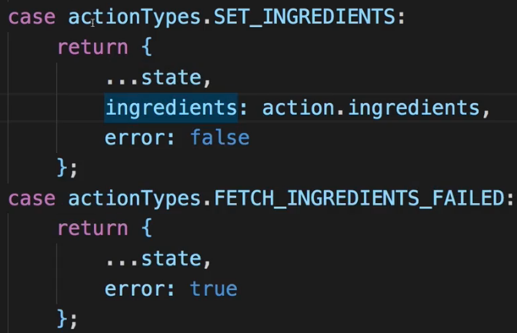  
* Now we need to connect our BurgerBuilder container.  
* Keep in mind thus far we have no different slices of state, we only have 1 REDUCER, we’re not combining any.  
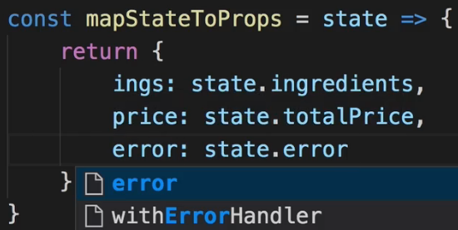  
* Also we need the `initIngredients`:  
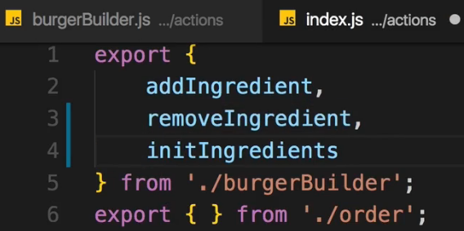 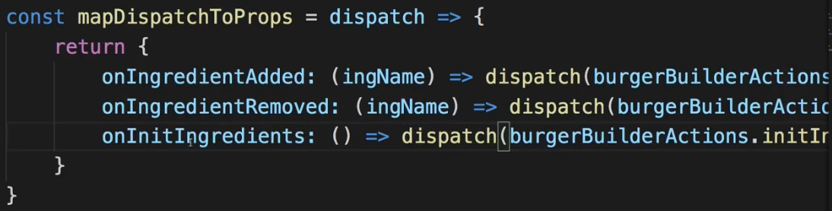  
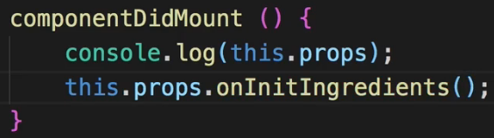  
* Now replace all occurences of `state.error` with `props.error`.  
* Error handling with HOC still works due to us using 1 and the same `axios instance`.  
* Next, let’s use Asynchronous code where we want to order a burger.  
**Changing the Order of our Ingredients Manually**  
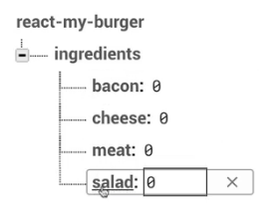  
=> The salad is at the bottom because since we load it from Firebase, and there we can’t order the properties manually, the salad is ordered at the bottom alphabetically and therefore it’s at the bottom here too.  
=> You would simply have to adjust your code to manually turn your ingredients let’s say into not just a number as a value but an object where you also define the position and then you would have to adjust your Frontend code to take care about this position too. OR you simply choose a solution where you hard-code your ingredients like this:  
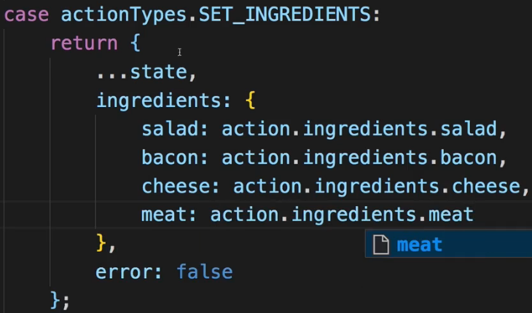 * Now the salad is at the top.  
=> This of course then loses a bit of the flexibility you had before where you could simply take advantage of setting up anything and then using it in your Frontend app, though you never had all of that flexibility anyways because we have only a limitted amount of ingredients supported with our CSS code here and the ingredients property where we also had a switch case statement.  
**Adding Order Actions**  
* Let’s now work on the checkout process. There we enter all that contact data.  
* I want to make sure that once we have a valid form and we click the “ORDER” button, we right now do of course submit that order and we do store that order on the Firebase server, but I want to handle more of that via Redux.  
* If we have a look at the `Checkout.js` container, there we don’t do anything to the checkout because we first of all load the ContactData container.  
* And in the ContactData.js container there we have that orderHandler() where we reach out to our Back End.  
=> This is what I now want to handle in an ACTION CREATOR so that we actually create our order in there and automatically add it to our STORE.  
* If we look at the ContactData container, we can actually split this up in a couple of ACTIONs we probably want to dispatch().  
* We want to start submitting this but then we also need ACTIONs for the success case and for the failure where we might want to set up some error or simply set loading: false if we don’t want to do anything with the error. So these 3 ACTION TYPEs probably make sense.  
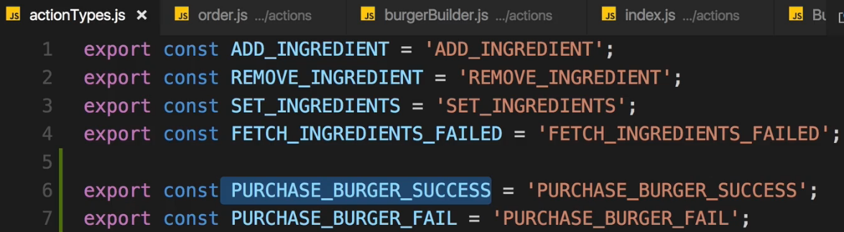  
=> I don’t have my TRY_PURCHASE ACTION here because we don’t need an identifier for that, it will only be an ACTION CREATOR we execute to run some Async code, it will never be an ACTION we dispatch() to reach to the REDUCER due to the Async code.  
* In `order.js` file in `actions`, creating ACTION CREATORs.  
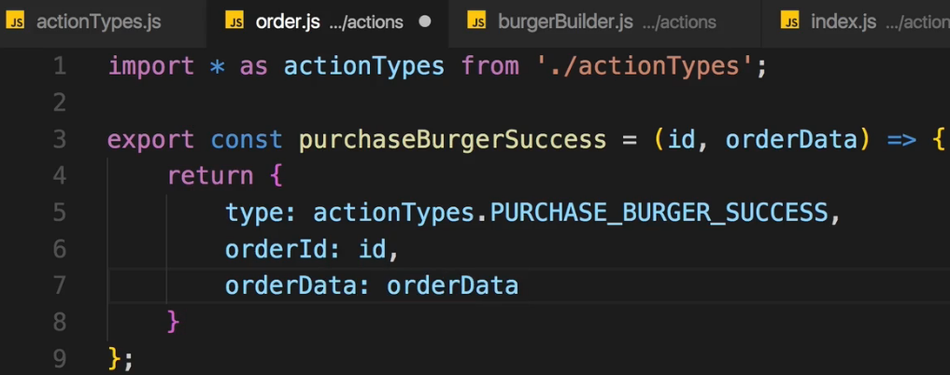  
* Here I expect to get the ID of the newly created order which was created on the Back End, on the database, because I want to pass it on in the ACTION which I actually create here, so that in the REDUCER we can use that ACTION to actually add the order to our `orders` array. And maybe I need more than the ID, maybe I also want to have the order data so I’ll pass the `orderData` object here too.  
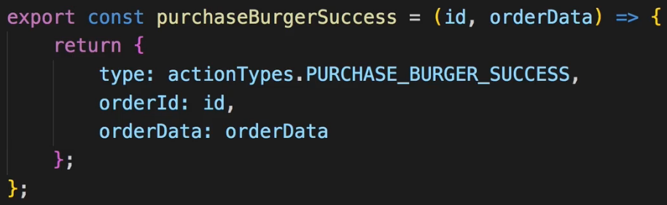  
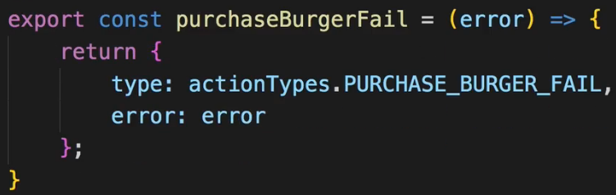  
=> These are 2 the Synchronous ACTON CREATORs.  
* Now let’s create the Async ACTION CREATOR, this is the ACTION we dispatch() from the container once we click that “ORDER” button.  
* We won’t call `this.props.history.push()` - we don’t have access to the Router here, we could get it, we could pass it as an ARGUMENT but I’ll take a different route of Redirecting later.  
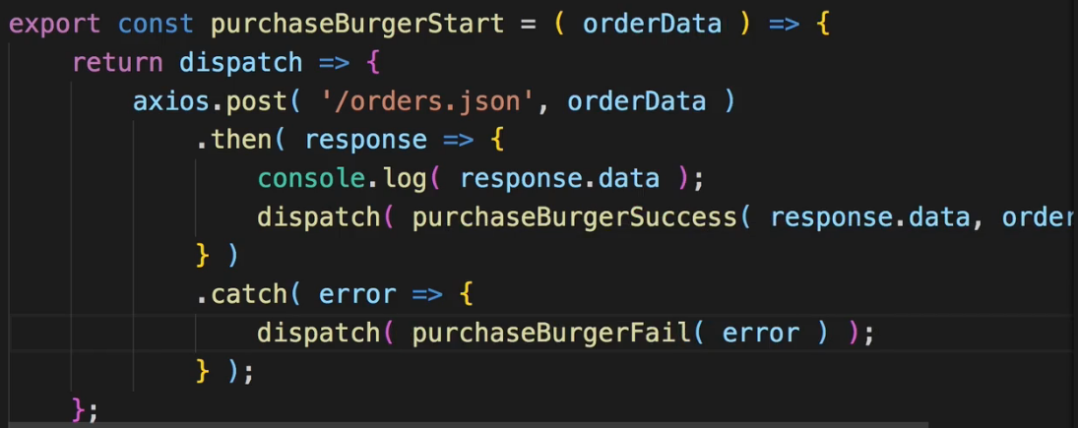  
**Connecting Contact Data Container & Actions**  
* In ContactData.js we have the orderHandler() method and I will leave it here because I still need it, it should be executed when we click the “ORDER” button, but I no longer want to handle loading here, and I no longer want to actually do the ordering here.   
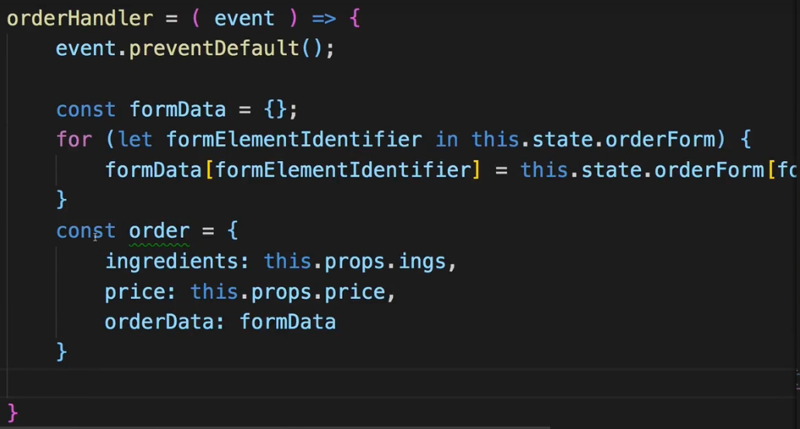  
* What I do want to do is I want to leave the axios import here, and I want to import **withErrorHandler** - that HOC. I don’t need to do that, it’s not related to Redux but I want to make sure that I do use it here too just as I use it in the BurgerBuilder.js at the bottom.  
  
  
* The main thing is that I want to connect my ContactData container here to the new ACTIONs.  
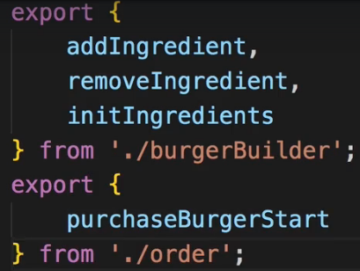  
  
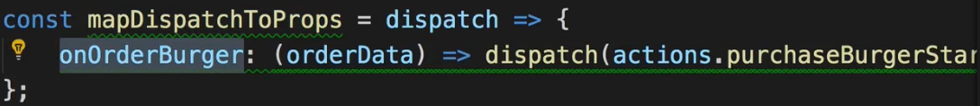  
=====🡺 This onOrderBurger should be inside a return statement.  
* Now I want to use the onOrderBurger property, it should be called in the orderHandler().  
* Remember we always receive our dispatch() ACTIONs as `this.props`.  
* Here the orderData is simply the detail order data the user entered into the form.  
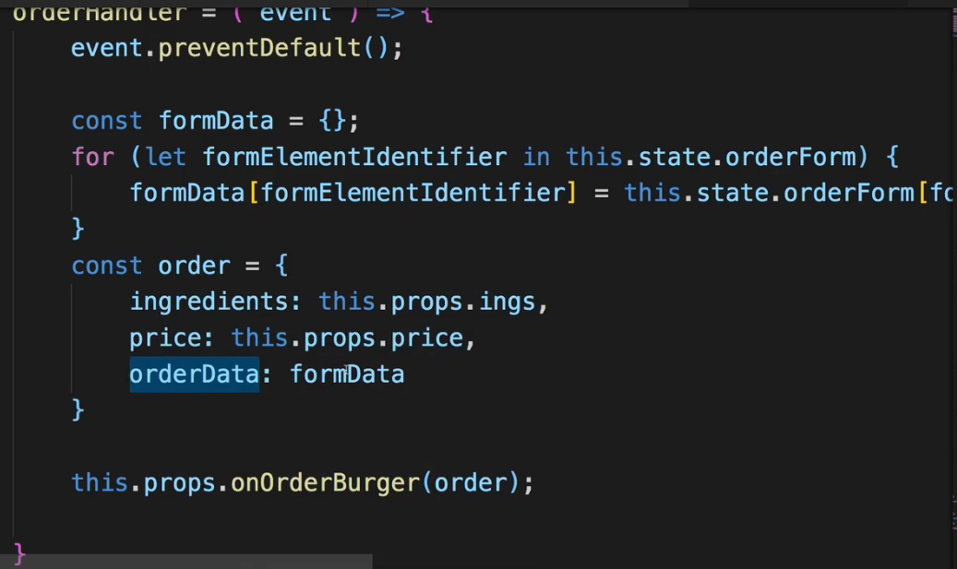  
* With that we’re able to dispatch() it on a click.  
* **But there are a couple of things which won’t work as expected anymore**.  
* For example in the render() method of the ContactData component, we check if we are loading:  
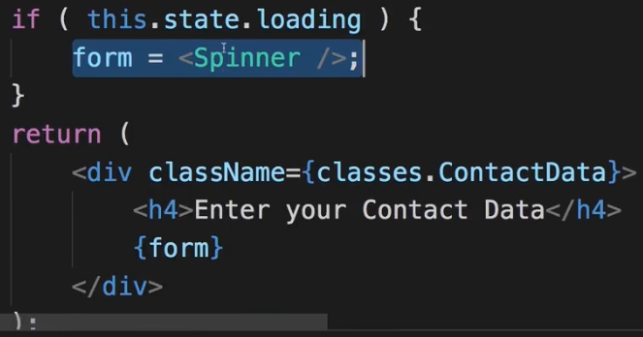  
* Now we are loading if we clicked the “ORDER” button.  
=> **We need to handle that `loading` state in our Redux STORE therefore, because we put the whole process of ordering into Redux**.  
* To be able to do so, we need to work on the `order.js` REDUCER which is pretty empty right now.  
**The Order Reducer**  
* We worked on the ACTION CREATORs for orders and we worked on being able to dispatch() them, now we need to manage the order state through our REDUCER of course.  
* In order.js in the `reducers` folder.  
* Now 1 issue we’ll face immediatelly is that in our order.js ACTION CREATOR in `actions` folder, we only handle success and fail, the purchaseBurgerStart ACTION here doesn’t actually dispatch() anything we can catch in Redux. We instead run some Async code to dispatch() other ACTIONs, which is a normal pattern, but since we probably want to update our loading property in our state when we start loading, we need an additional ACTION we dispatch(). I’ll handle that in the next lecture.  
* In this lecture, let’s work on the ACTIONs we already have.  
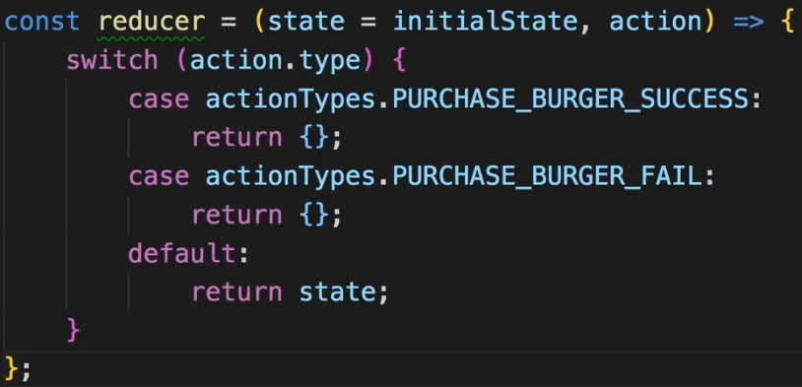  
=> With the `default` we also make sure that we return something if it’s an ACTION which is handled in a different REDUCER.  
* **.concat() returns a new array and therefore we edit this immutably**.  
* This is the ACTION CREATOR by the way:  
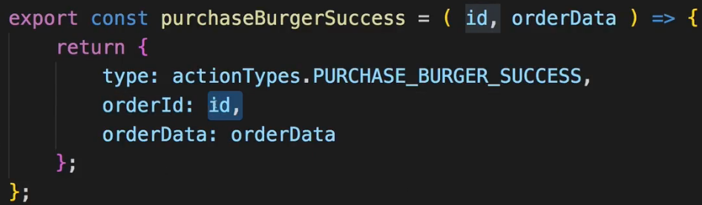  
* Now let’s work on the logic.  
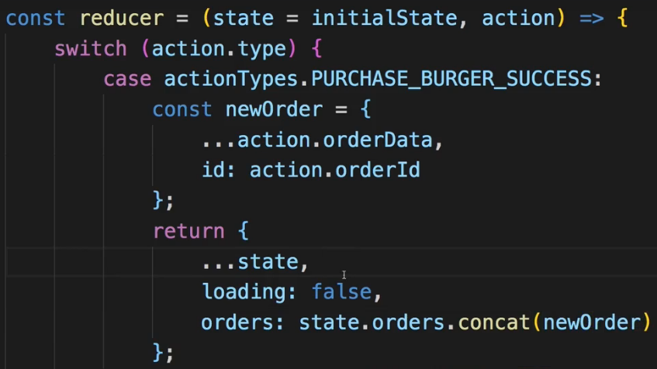  
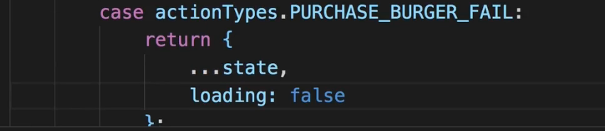  
* In the fail we also set `loading` to false because even if it failed, we’re still done and the error should be handled through that Modal since we added the withErrorHandler HOC to ContactData.  
**Working on Order Actions**  
* Let’s start by setting loading: true when we start fetching a burger.  
* For that I need a new ACTION TYPE.  
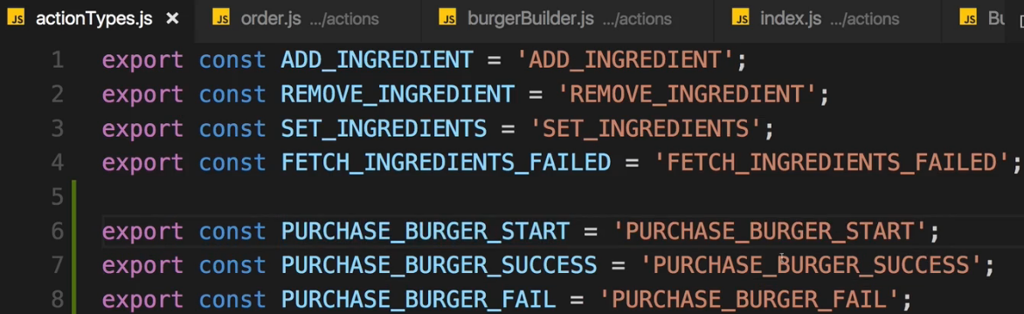  
=> We named the Async ACTION CREATOR like this - let’s rename it.  
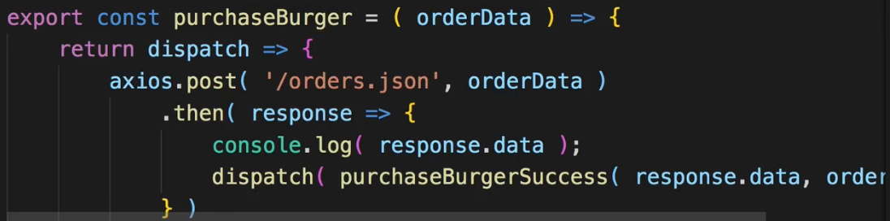 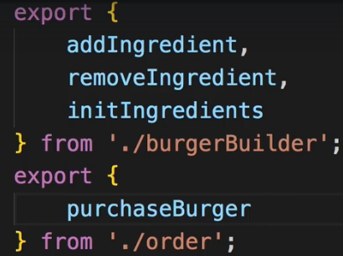  
* In ContactData.js.  
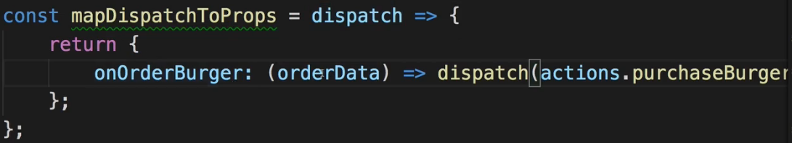  
* And let’s create a new ACTION CREATOR.  
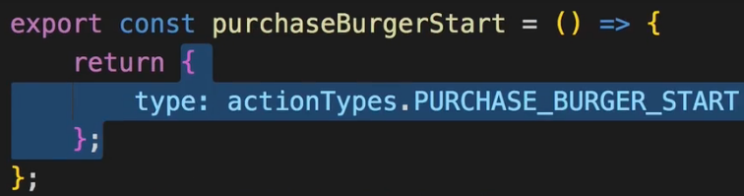  
* Now we want to use it inside purchaseBurger ACTION CREATOR.  
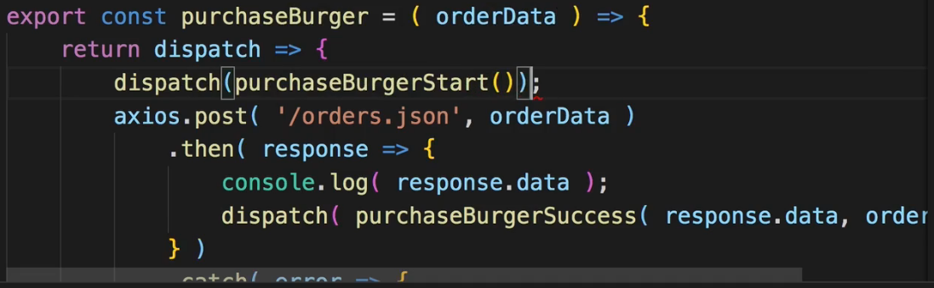  
* Now let’s handle this new ACTION in our order.js REDUCER.  
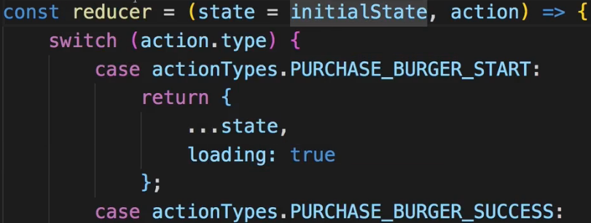  
* In ContactData.js we have to make sure that we get `loading` from Redux STORE because we’re using `loading` to show the Spinner.  
* So in mapStateToProps I’ll add the `loading` prop and map it to `state.loading` - and now we can reach out to `state.loading` but actually we’ll soon combine our REDUCERs so we will have to change this soon to take the slice off the order.js REDUCER here in mapStateToProps in the ContactData container.  
* I’ll keep it like this for now, but we’ll soon change it:  
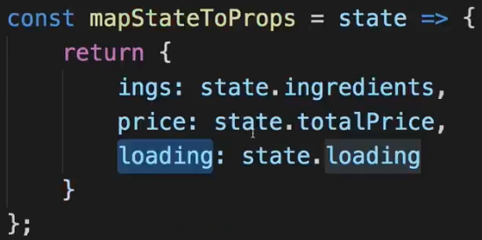 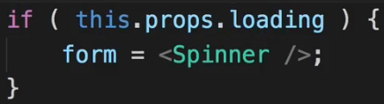  
* The last step is to also use mapDispatchToProps and add it to the connect() function and pass it as the 2nd argument so that this really is considered by react-redux.  
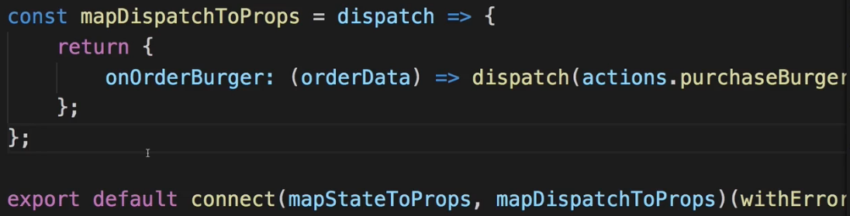  
* Now nothing would work:  
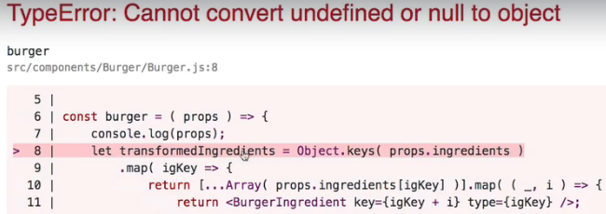  
=> We’re trying to fetch the ingredients, and this doesn’t work.  
=> And we also will never be able to reach our other state here - the order state - becauase we’re not combining any REDUCERs.  
* So let’s first fix the error and then work on combining REDUCERs  
**Redirect to Improve UX**  
* We got the error on the checkout page:  
  
=> The reason for this is that on the Checkout.js page in the CheckoutSummary, we of course show a preview of our burger with the ingredients we have. And initially before we loaded the ingredients, ingredients is null. And therefore it fails if we try to loop through our ingredients.  
* Now there are a couple of ways of solving this.  
=> Easy way is to simply not load the CheckoutSummary if ingredients aren’t loaded yet. We can either show a Spinner until they’re there but since in our application at least - the only time when ingredients are not there is at startup - we could also simply Redirect the user if no ingredients are loaded because if no ingredients are there, well then it doesn’t make any sense to be on the Checkout page. So that’s the route I’m going to take.  
* In Checkout.js.  
  
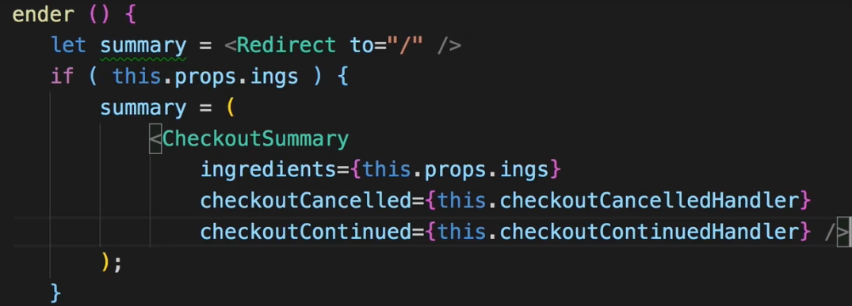  
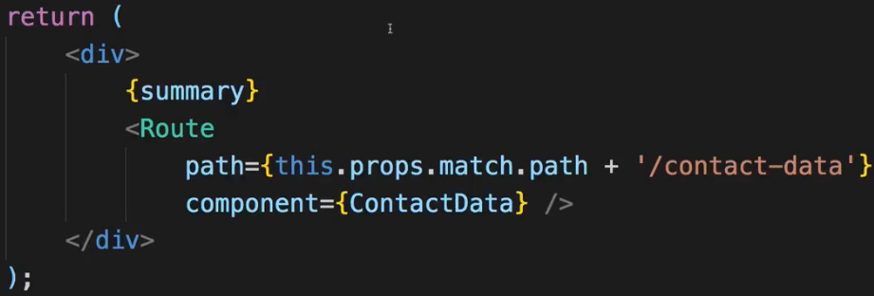  
* On that “/” BurgerBuilder page I have a loader as long as no ingredients were loaded.  
* And we also don’t need to show the Route to the “/contact-data” so I can simply put this into my summary, wrap it with a DIV due to having adjacent elements here.  
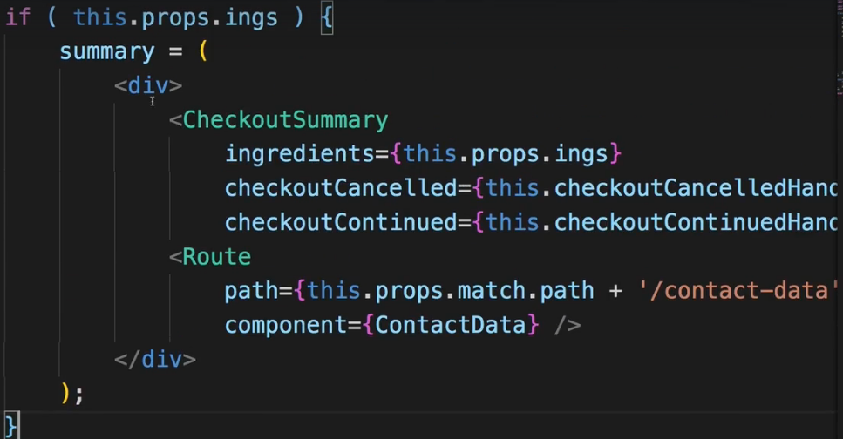  
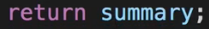  
* So this is the error fixed.  
* Now let’s make sure that we actually combine our REDUCERs.  
**Combining Reducers**  
* We got 2 REDUCERs in `reducers` folder: burgerBuilder.js and order.js.  
* So in our main index.js file it’s time to combine REDUCERs.  
  
  
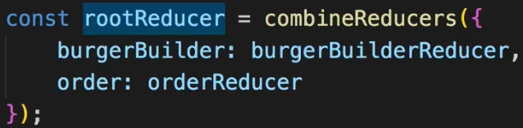  
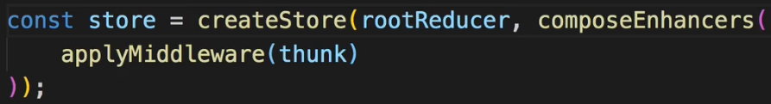  
=> **With that the whole application will break because now we have different slices of state: `burgerBuilder` and `order`**.  
=> So I need to go to my containers and update.  
* In BurgerBuilder.js container:  
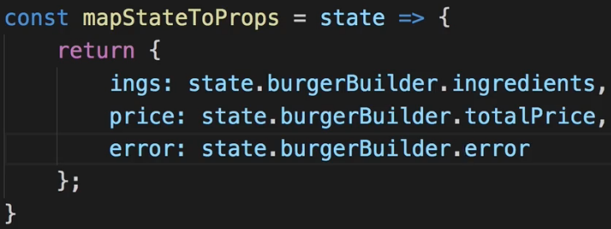  
* In Checkout.js container:  
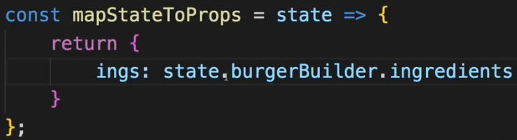  
* In ContactData.js container:  
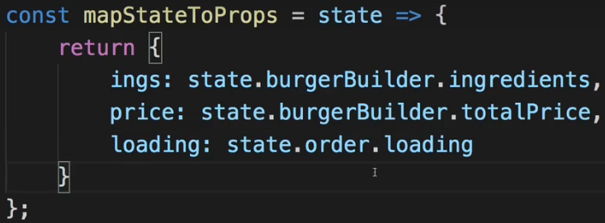  
* Everything seems to be working, let’s see if we can successfully fill out the form.  
=> After submitting, we saw the loading screen, we got something back from the server, that’s looking good.  
=> Let’s have a look at Redux Devtools, I see at least 1 thing which won’t work as expected.  
=> We got PURCHASE_BURGER_START and we saw the Spinner for a second so that worked.  
=> And PURCHASE_BURGER_SUCCESS and in there we see that the `orders` were updated and we added this new object here where we have our ingredients and then store some data in it:  
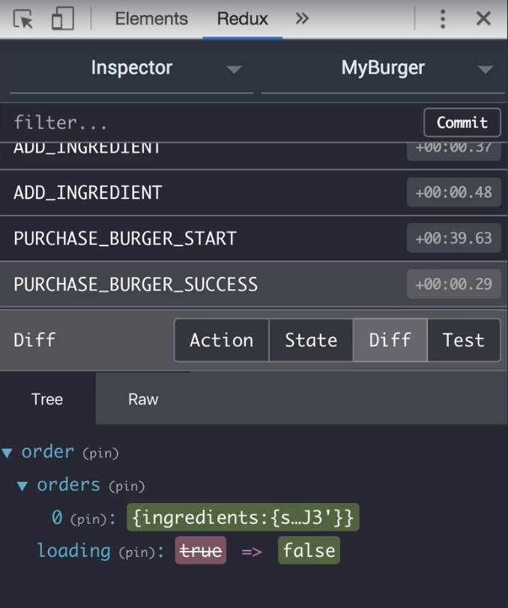  
=> **If we have a look at the STATE, we can expand our orders, have a look at that order and we see tat this order here has an ID which is not correct, I should’ve extracted the name properties so that’s 1 thing we need to adjust**.   
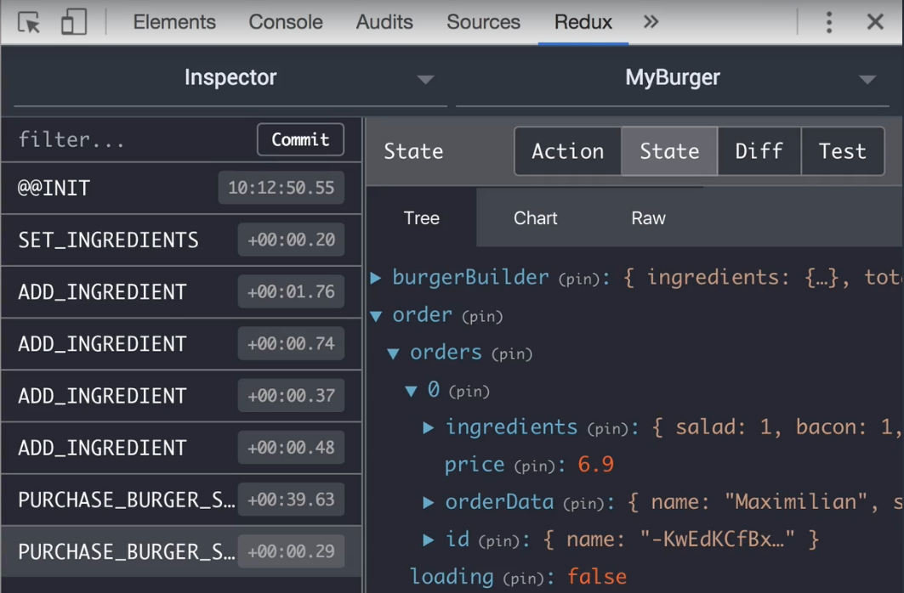  
=> Besides that, all of that seems to be working rather good.  
* **Of course, we’re not Redirected once we’re done**.  
=> **So this ID thing and being Redirected. That are the things I want to fix**.  
* Let’s check in Back End:  
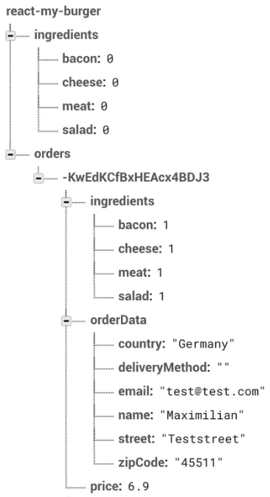  
=> **deliveryMethod wasn’t passed on I see so that is something we should also fix**.  
* Let’s quickly fix the issues we found.  
* 1 is in the ContactData.js here where we submit the form - the thing is: if we never adjust the Dropdown value, then the value’s actually empty and it shouldn’t be.  
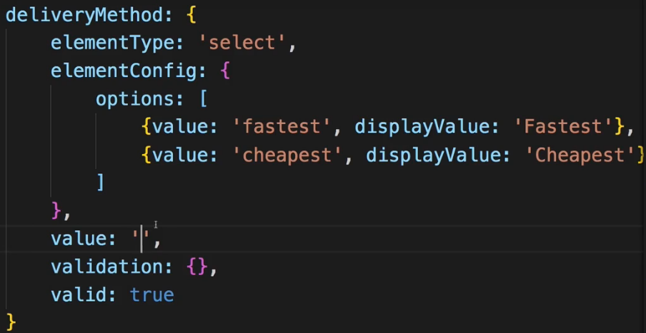 => 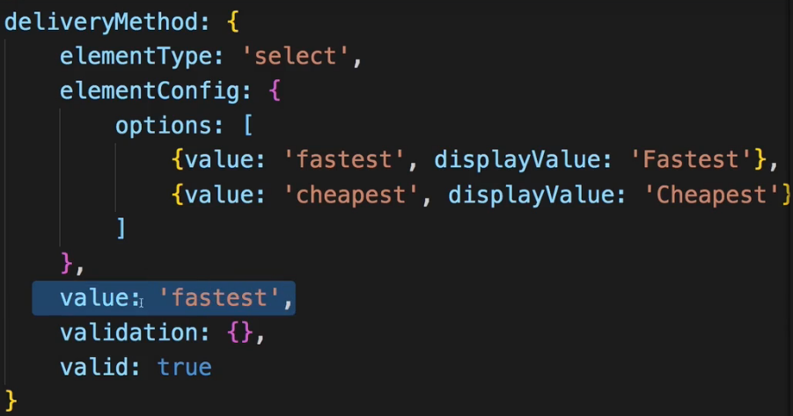  
=> It should be let’s say ‘fastest’ by default.  
* So I just added this to the value property in the deliveryMethod object in the state of the ContactData.js. That’s 1 important adjustment to have this work correctly.  
* Now 1 other thing is - in the REDUCER in order.js, when we have a success and we get the ID the `action.orderId` - that’s the wrong ID.  
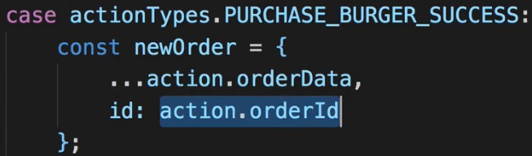  
=> Because in the `actions` folder in the order.js, where we pass on the ID, I pass on `response.data` as the ID. But instead we just saw in the console.log() that it’s on the `response.data.name` property of the data, that is the ID we want to store.  
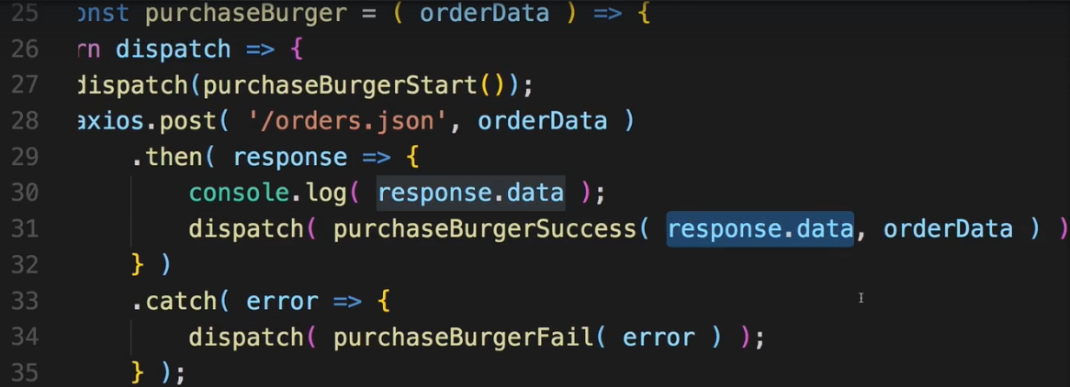  
* But with that, we have this working.  
* The only missing thing is that we Redirect, that we route. And I’ll do that in the next lecture.  
**Handling Purchases & Updating the UI**  
* Now there are various way of implementing Redirection.  
=> 1 thing is - you could pass a reference to that router history prop onto your order ACTION CREATOR and when you dispatch success you could then use that if you receive it as an argument, to call the .push() method on it. I don’t like this approach too much though but you can definitely do that.  
=> The approach I’ll use is a Redux-only approach.  
=> I’ll add a new ACTION TYPE.  
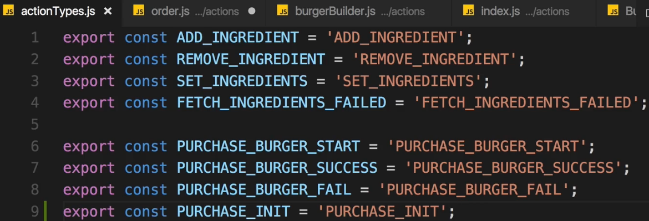  
=> This will be dispatched whenever we load the Checkout page.  
=> Let’s create an ACTION CREATOR in `actions` order.js for it.  
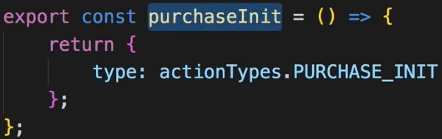 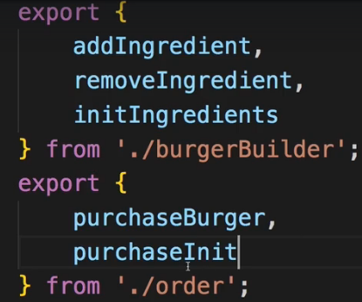  
* In Checkout.js:  
=> And dispatch() this ACTION in **componentDidMount()** or we’ll use **componentWillMount()**.  
=> In the REDUCER I then want to add a new property to our state where I set something like `purchasing` to false which is set to true once we did finish the purchase so that we then Redirect.  
  
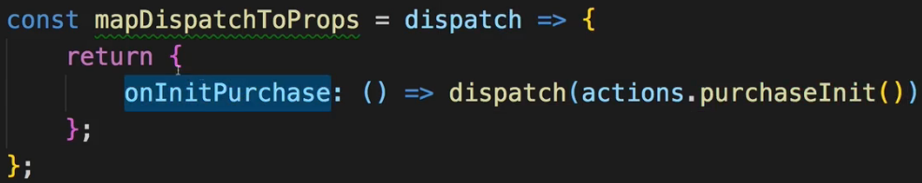  
  
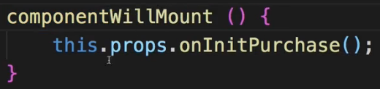  
* Now in the order.js REDUCER:  
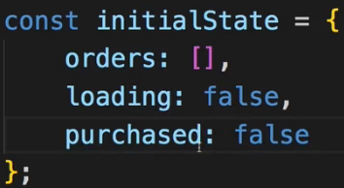  
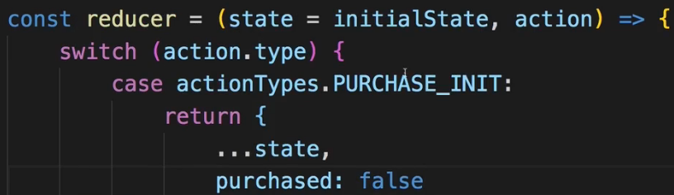  
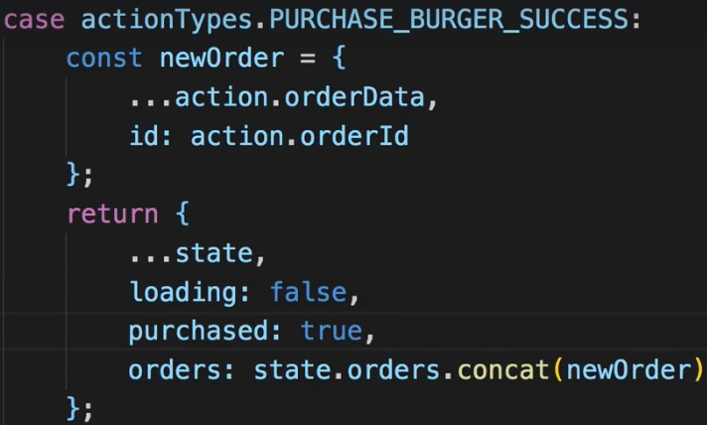  
=> Set `purchased` to false in INIT and set it to true in SUCCESS.  
* So now `purchased` changes as soon as we did successfully purchase but is always reset once we revisit the Checkout container.  
* In Checkout.js we can now Redirect:  
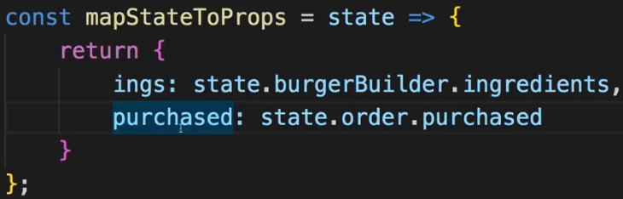  
 : null  
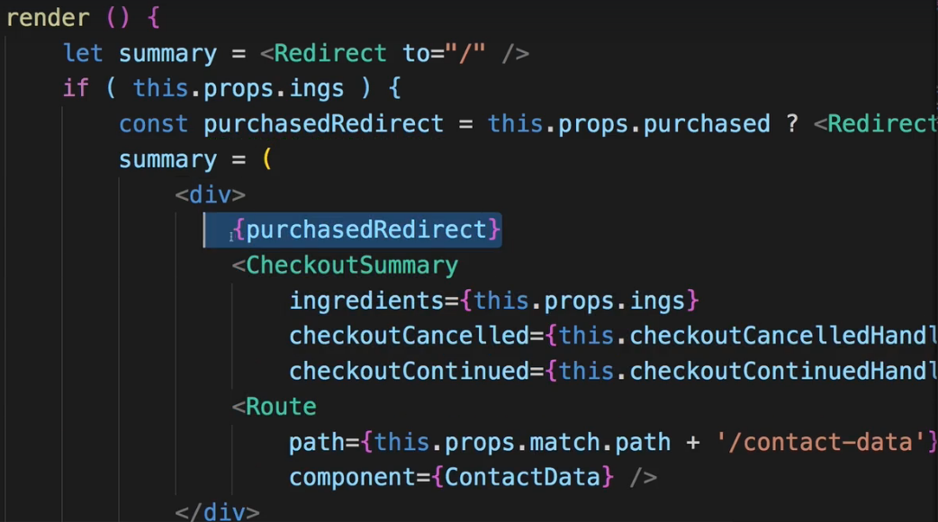  
* Now when we finish the form and submit it, we are Redirected to home.  
* But now if we then add a new burger and click “ORDER NOW” > “CONTINUE” we again are Redirected. Why?  
=> It’s related to the place where we call onInitPurchase() => componentWillMount() in the Checkout.js container is too late. While it does run before render() runs, it doesn’t prevent the rendering with the old props we received and in the old props `purchased` is still true.  
=> So we can’t dispatch() this here in componentWillMount(), let’s remove it.   
=> Let’s also get rid of the mapDispatchToProps in Checkout.js and remove it from connect().  
=> Instead, we want to INIT the purchase in the BurgerBuilder.js when we click on the “ORDER NOW” button.  
=> So here, `purchaseContinued` in the end:  
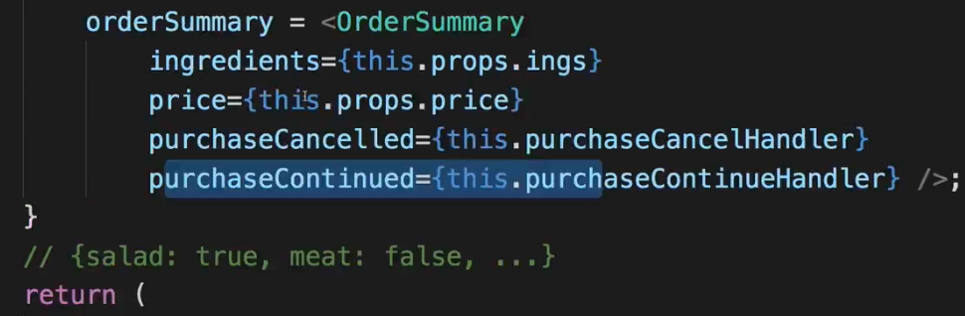  
right before we .push() to the Checkout page.  
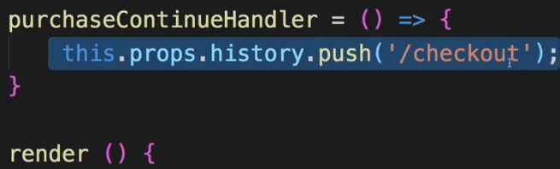  
=> That’s the place where we want to initialize a purchase.  
=> To do this, I’ll simply add a new ACTION I can dispatch() in mapDispatchToProps.  
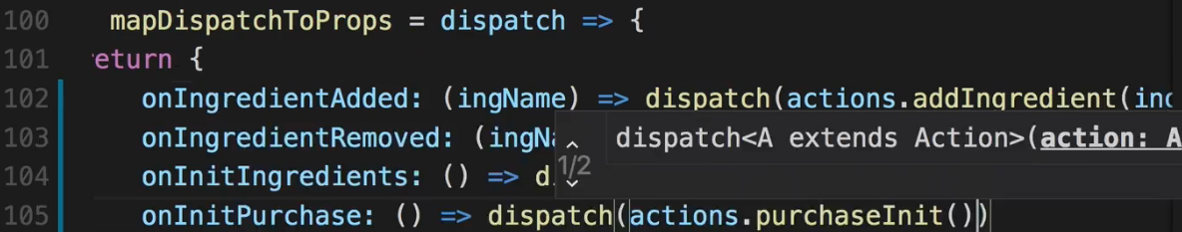  
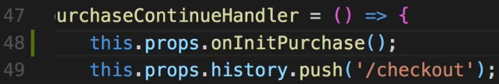  
* **We got 1 flaw - our price never resets after Redirecting**.  
**Resetting the Price after Purchases**  
* The price never resets because in our burgerBuilder REDUCER where we manage the total price, we only update the price when we add/remove an ingredient but we never reset it when we call SET_INGREDIENTS, the SET_INGREDIENTS ACTION is dispatched whenever this BurgerBuilder page is loaded though. We do it in componentDidMount() in BurgerBuilder.js.  
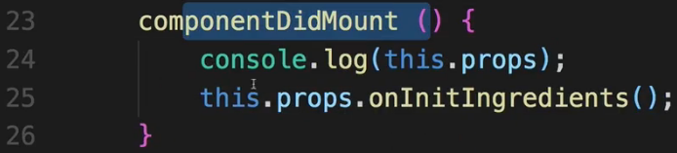  
=> And that’s on purpose - I want to load my ingredients and reset them whenever this component gets mounted.  
=> Now for that reason since we’re doing it here, we have the issue of not updating the price.  
=> We can easily fix this - in the burgerBuilder REDUCER where we call SET_INGREDIENTS and update the ingredients, we simply also have to update the total price and we could get this value for the server too or we simply hard-code it.  
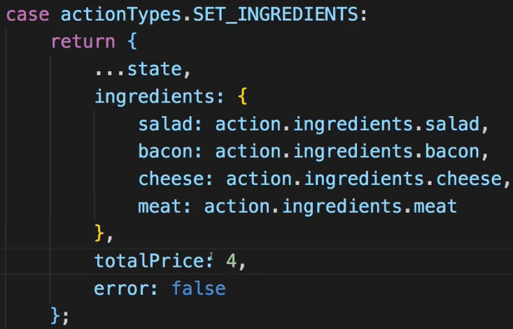  
* Now we will have an updated price.  
* Now it’s time to work on the orders page.  
**Fetching Orders (via Redux)**  
* On the “Orders” page we do see the order. But we’re not using Redux for it, here we’re reaching out to the web in componentDidMount().  
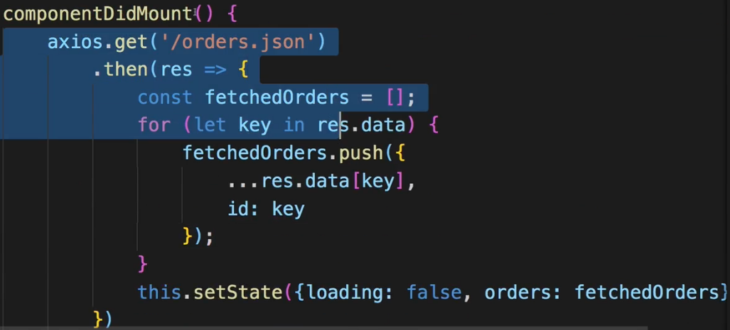  
=> Of course I want to fetch my orders through an ACTION CREATOR and I want to manage my orders through Redux - we already created that orders: [] array in our state there, we’re just not using it.  
* Let’s name it FETCH_ORDERS_START maybe so that we have a similar pattern as for the purchase where we can set `loading` to true, and then trigger this starting process where we reach out to the web and then we have the success case and so on.  
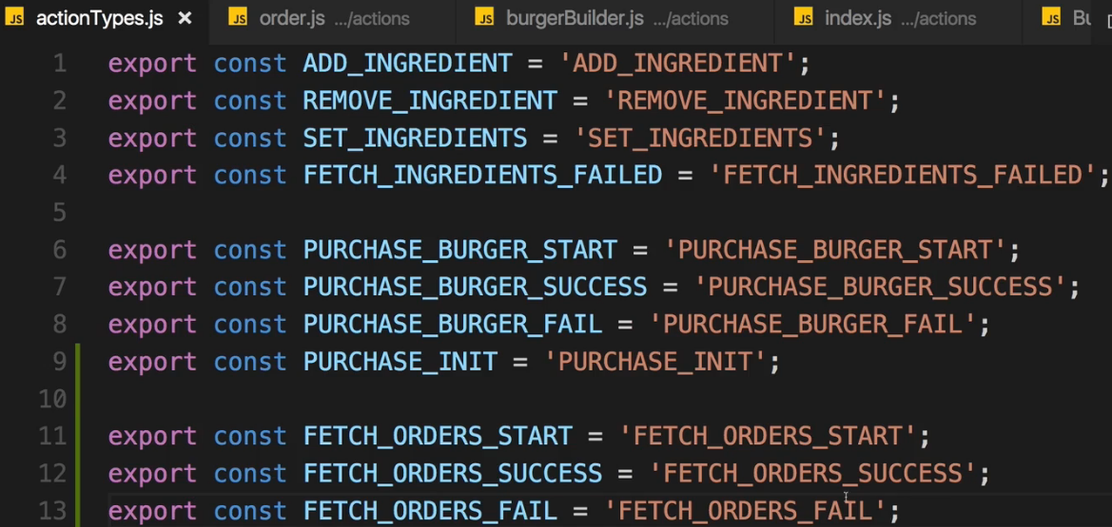  
* Now let’s create the ACTION CREATORs in order.js in `actions`.  
* I’m going to use a similar pattern as for purchasing burger, where we also have success, fail and start and purchaseBurger itself which is dispatched from a container which does the Async code part.  
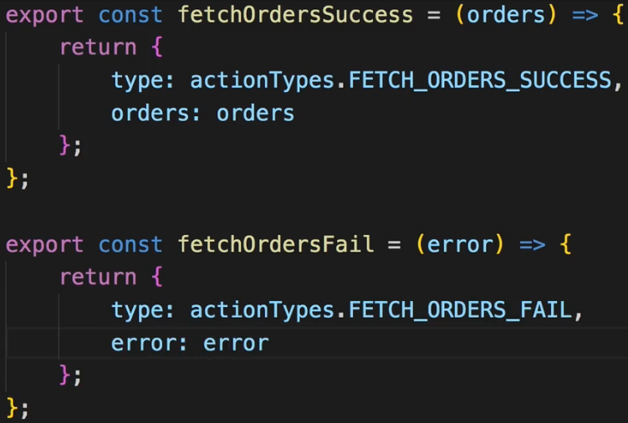  
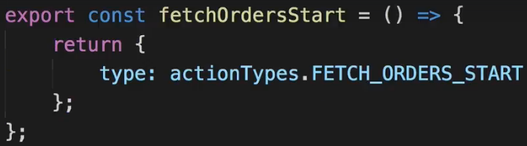  
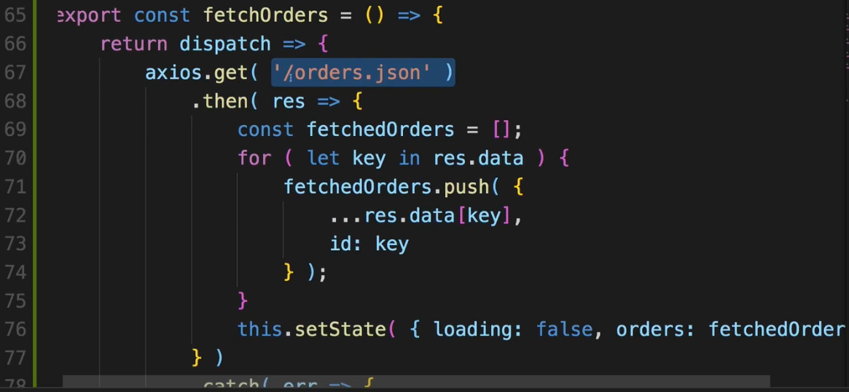  
=> We won’t call this.setState() though.  
* I pass to the success the fetchedOrders which I do transform here - and that is a good argument for where do we transform data - I do it here because I’m transforming the data I’m getting back, I don’t want to put this into the REDUCER because if I ever change my Back End data, I would have to change my REDUCER and it feels more natural for me to have a REDUCER where I get the data in the format I want to store it, where I only wann do logical changes and don’t want to change anything just because of the data format.  
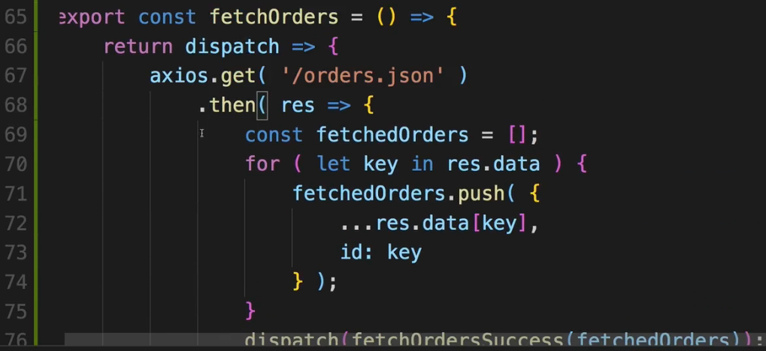  
* Now in the order.js REDUCER:  
* We use the same `loading` property we use in the Checkout page but we’re only either on the Checkout page or the Orders page so it’s fine if we reuse the property on both pages.  
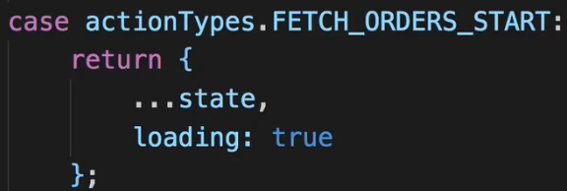  
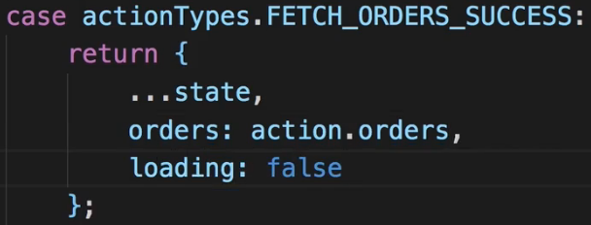  
* In FAIL we could handle the error, we could store the error in the `error` property here but I don’t want to use it here, I’ll do simply loading: false because even though it failed, the loading at least, is done.  
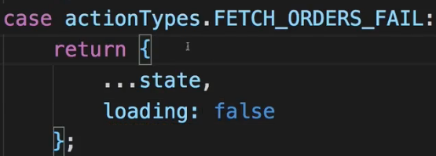  
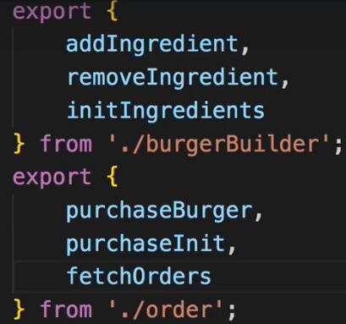  
* Now in Order.js container we can connect it.  
  
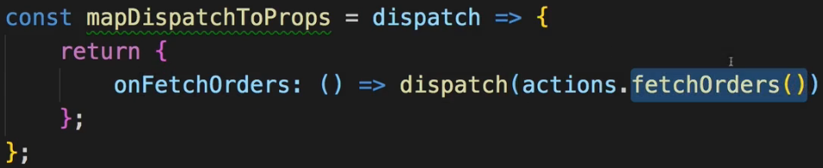  
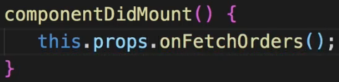  
  
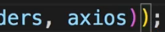  
* Now this should work, I’m of course also interested in the state though because I need my Orders. Right now we manage `orders` and `loading` in th internal state, let’s get rid of that.  
* Let’s add mapStateToProps, with `state.order` I’m reaching out to ther order REDUCER and with `.orders` I then reach out to the `orders` property in the state of that REDUCER.  
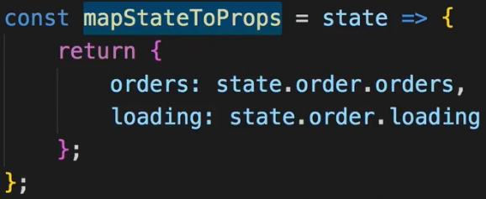  
  
* And now change `this.state.orders` to `this.props.orders`.  
* And if we wanted to show the Spinner, we would have to import it.  
  
=> And let’s use this `loading` state.  
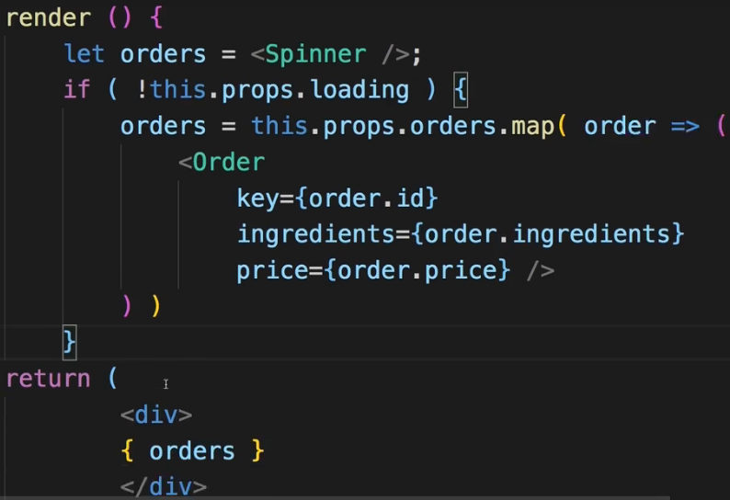  
* I got my orders but I never see the Spinner - the reason for this is that in our order.js ACTION CREATOR file in fetchOrders, we never dispatch() fetchOrdersStart. I need to do that of course to set `loading` to true.  
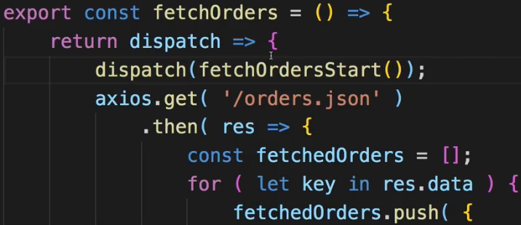  
* With that we’re now fetching the orders through Redux, we’re managing them in our STORE and we do manage them both when we place an order and when we visit the orders page.  
* Side-note: since we always load orders when loading the Order.js container, it doesn’t really matter that we also store an order on a successful purchase - in the order.js REDUCER in PURCHASE_BURGER_SUCCESS where I store this new order, that doesn’t really matter because we load orders from the server anyways when we visit the Order page.   
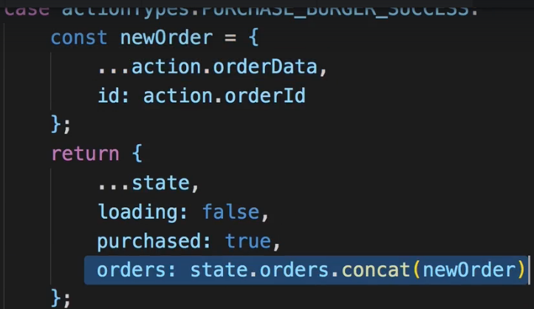  
* But we can confirm in our Redux Devtools that we do store it befor we fetch it from there and it’s of course nice to know how we could store a new order programmatically without reaching out to the server in case we needed that on some other page too.  
**Checking our Implemented Functionalities**  
* This is all working fine, we got a nice working application.  
* Now you could add a delete button to get rid of orders but I want to focus on code enhancements and implement some of the things I touched on in the last module - for example how we can make our REDUCERs a bit leaner, without splitting them up even more.  
**Refactoring Reducers**  
* These refactoring techniques are all optional.  
* It can clean up this REDUCER and make the `switch case` statement a little bit leaner.  
* Let’s for example add our updateObject() CONVENIENCE METHOD.  
=> In the `store` folder let’s create a utility.js.  
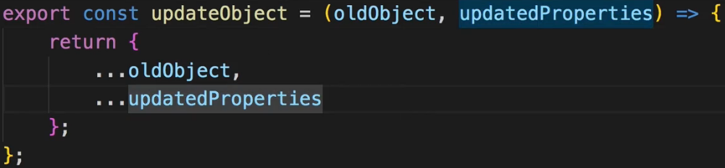   
* It’s a named export so we need the {}.  
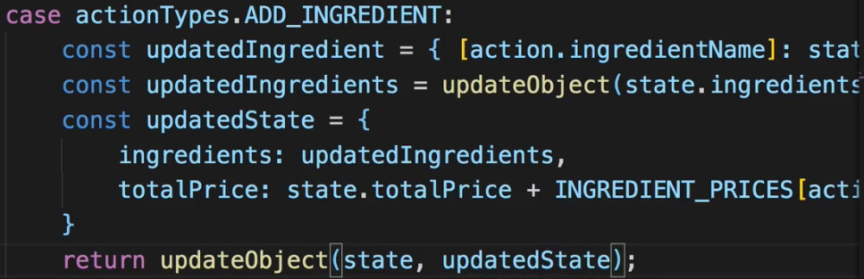 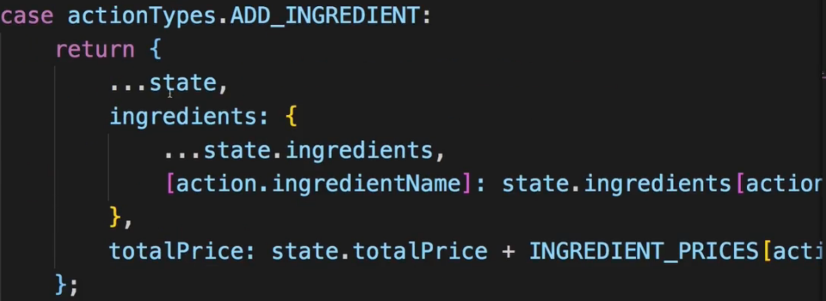  
* It's not just about the amount of lines of code but also about readability and grouping functionalities/ methods together. That's the idea behind this approach.  
* So still a lot of lines, a little bit more strucutred.  
* We could’ve squeezed all of that into 1 line but that would be really hard to follow along.  
* If the IDE Doesn’t like using the same const names in the other case parts, we have to rename it.  
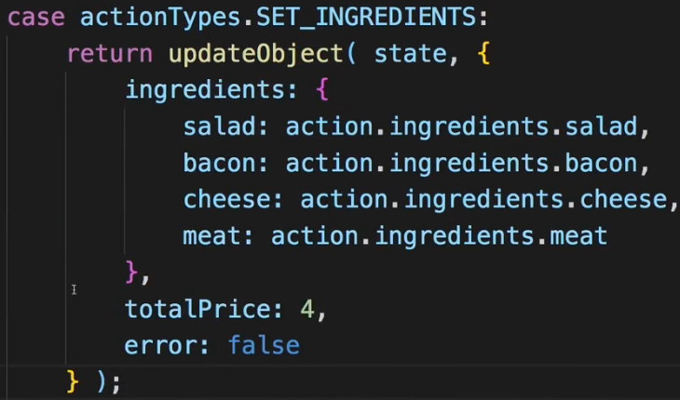  
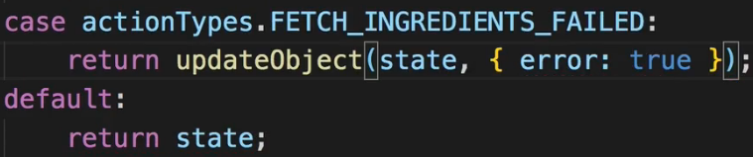  
* So that is the ingredient (burgerBuilder) REDUCER updated with our utility function.  
* Let’s now do the same for order.js REDUCER.  
  
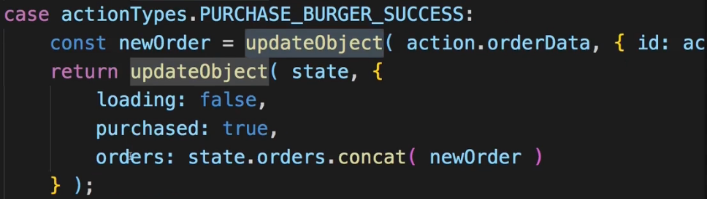  
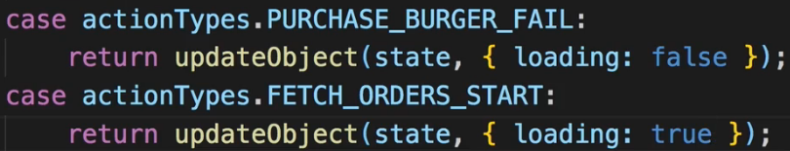  
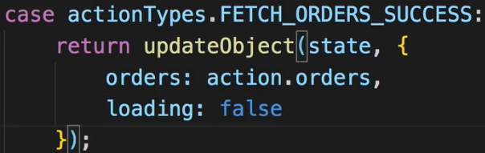  
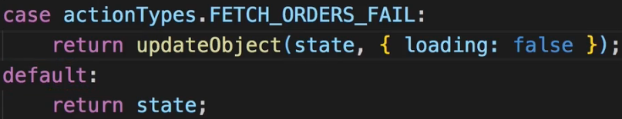  
* Again, all of that is optional but it does reuse that UTILITY FUNCTION and if we ever were to change the logic you use for updating object, you only have to do it in 1 place.  
**Refactoring Reducers Continued**  
* 1 other thing we can also do is: we can extract the logic from out cases into their own functions. So that our `switch case` statement becomes very short.  
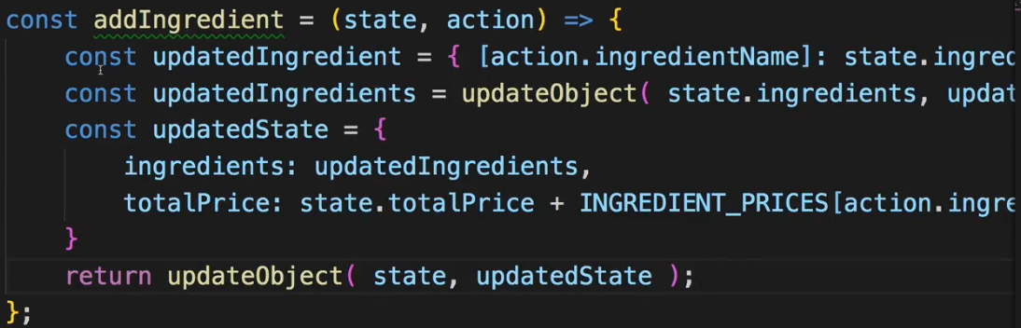  
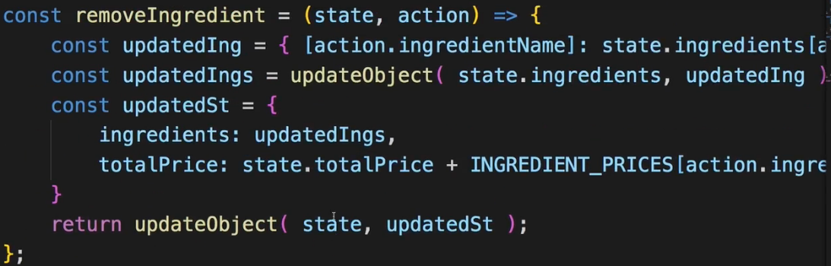  
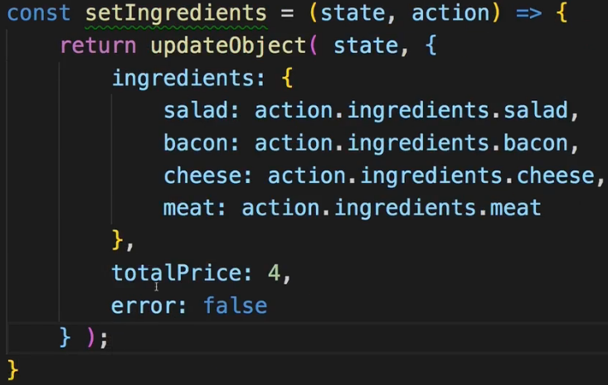  
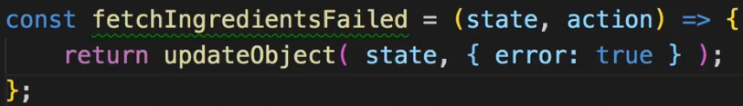  
=> With that we got a super lean REDUCER.  
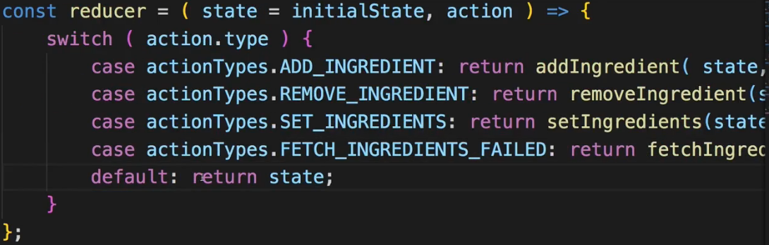  
=> So the idea behind this of course is not to shrink our file, it’s as long as before - even a bit longer, but the `switch case` statement is much leaner and we can quickly see which cases are handled in the REDUCER. And that’s the whole idea behind that.  
* Now we can do the same for the order.js REDUCER.  
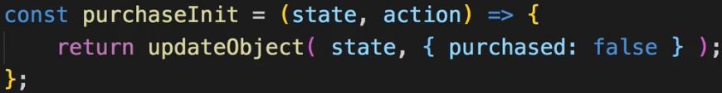  
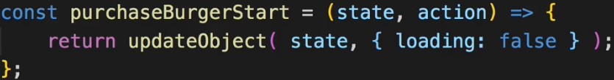  
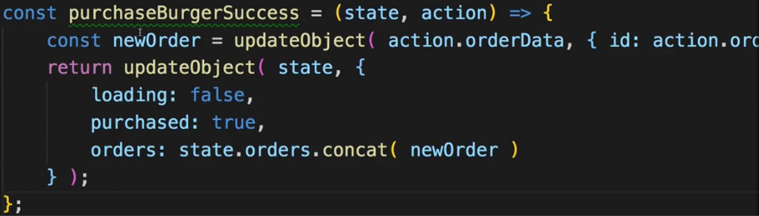  
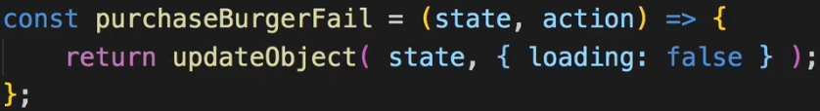  
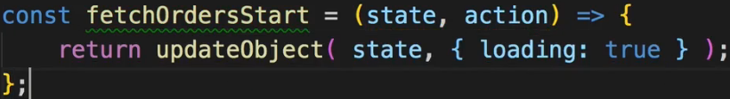  
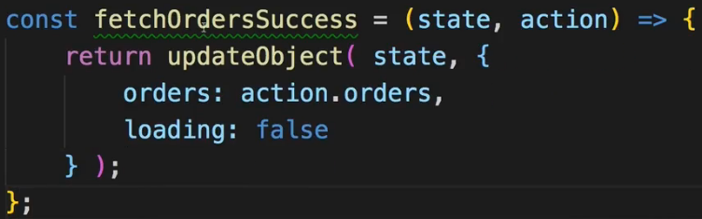  
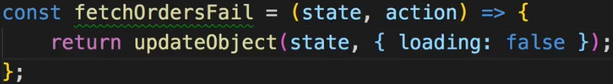  
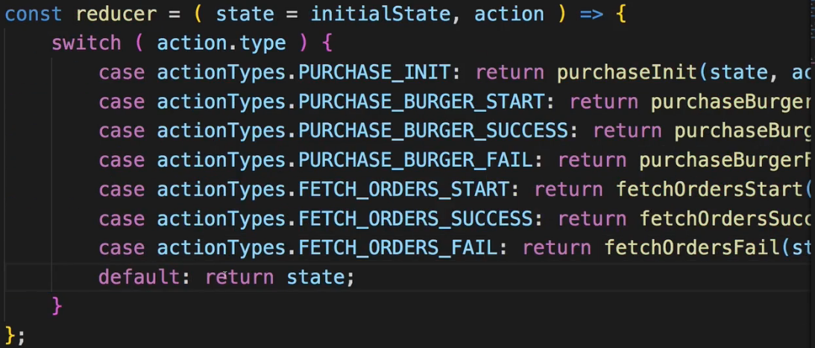  
* With all that in this module, we implemented some Advanced Redux techniques into our Burger Builder application.  
* You can of course enhance it for example by making the orders deletable or viewable that you have a Details page for each order, whatever you want.   
* I like the application as it is right now, we implemented a lot of cool features, a lot of React and Redux stuff and with that I feel very comfortable to move ahead and implement AUTHENTICATION.  
**Wrap Up**  
* We added a lot of logic in this module.  
* We now really have an Advanced Redux usage with refactored REDUCERs with lean `switch case` statements.  
* We’re handling Asynchronous code with ACTION CREATORs.  
* We’re applying MIDDLEWARE in our main `index.js` file to have redux-thunk being added to be able to have Async ACTION CREATORs.  
* We’re doing a lot of stuff with Redux and we still - and that’s also important - we don’t do everything with it because we don’t have to manage everything with Redux as I showed you - it’s fine to still manage some state like a Modal if it should be shown or not, through the Local UI State.  
* The next step is to add AUTHENTICATION to it since this is another CORE FEATURE a lot of apps use and I want to show you how to add it the React way.